*Florida International University*

*School of Computing and Information Sciences*

CIS 4911 - Senior Capstone Project

Software Engineering Focus

Feature Document

User Story #973

**Team Member: Vladan Lalovic**

**Product Owner(s)**: Mohsen Taheri

**Mentor(s)**: Mohsen Taheri

**Instructor**: Masoud Sadjadi

**User Story** - Improve functionality of Profile Page

**Description -** As a Developer, I want to test and make sure that the Profile Page works correctly for the different user groups, so that Users can properly use the site.

**Acceptance Criteria**

1. The “Profile Page” should automatically be refreshed when you update the profile. (<http://vip.fiu.edu/#/profile>)
2. After a user updates their profile, a message should be displayed at the bottom of the page indicating whether or not the changes need Pi/CoPi approval.
3. “Students” and “Faculty/Staff” should be allowed to update all parts of their profile without Pi/CoPi approval, except for their “userType”. This doesn’t apply if the user was approved as a Pi/CoPi previously.
4. Once a user has been approved as being a “Pi/CoPi”, that user can change/update all fields in their Profile, including switching their “userType” between Pi/CoPi, Faculty/Staff, or Student whenever they want, without approval.

**Use Case - Profile Page Functionality Improvement**

**Use Case ID:** (VIP-973)

**Details:** Testing and Fixing the “Profile Page” so that it works as intended for all Users. This includes having the “Profile Page” automatically refresh after the User updates some information. It also includes having the Page send an email to the PI to approve the profile updates.

**Actor:** Developer

**Pre-conditions:**

1. Developer logs into all 3 types of user accounts (Student, Faculty/Staff, and Pi/CoPi) to test the Profile Page features.
2. The accounts being used to perform the tests have been previously verified and approved via email.
3. Developer has navigated to the “Profile Page” (<http://vip.fiu.edu/#/profile)>.

**Description:**

1. Use case begins when the Developer navigates to the “Profile Page” (http://vip.fiu.edu/#/profile).
2. Developer will change his/her “User Type” and/or “Rank” to a different value using the respective drop-down menus.
3. Developer will click on the “Update” button at the bottom of the page to confirm the changes.

**Post-conditions:**

1. The “Profile Page” will refresh and display 1 of 2 possible messages that indicate success.

* The message “Profile Updated. Waiting for PI Approval.” Indicates that the user needs permission from a Pi/CoPi to update their userType.
* The message “Profile Updated.” Means that all requested profile changes have been performed, and no Pi/CoPi approval is required.

1. If required, an email will automatically be sent to the Pi/CoPi that the User is attempting to Update his/her profile.
2. The Users profile will remain the same until the PI has approved the changes.

**Alternative Courses of Action:**

N/A

**Exceptions:**

N/A

**Related Uses Case:**

1. Login
2. Nodeemailer

**Modification History:**

**Owner:** Vladan Lalovic

**Initiation date:** 5/28/2016

**Date last modified:** 6/20/2016

**Use Case Diagram**

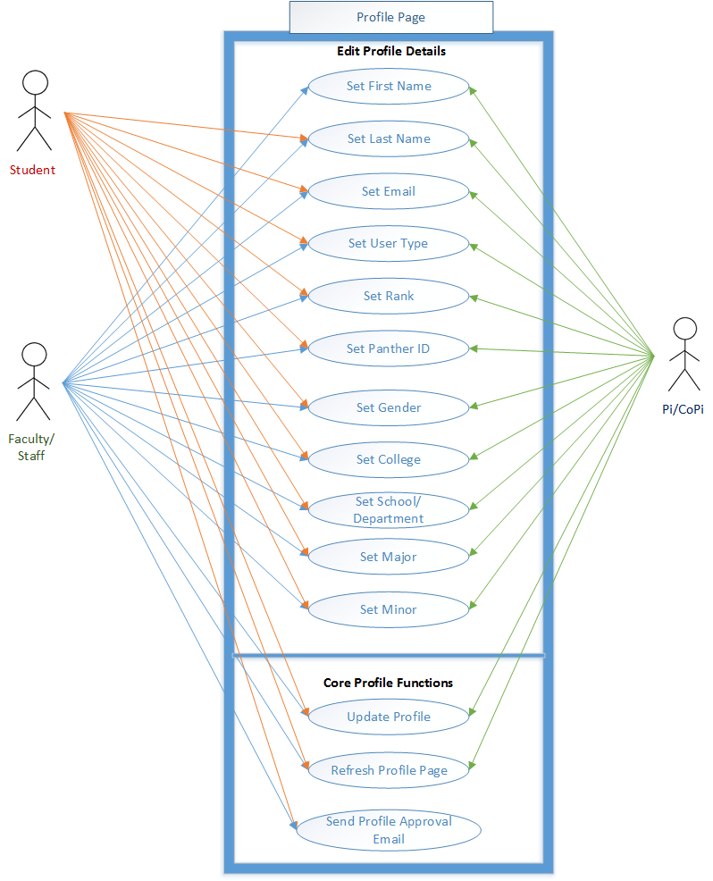

**Class Diagram**

## C:\Users\Admin\Desktop\Senior Project\973 - Class Diagram.png

## Sequence Diagram

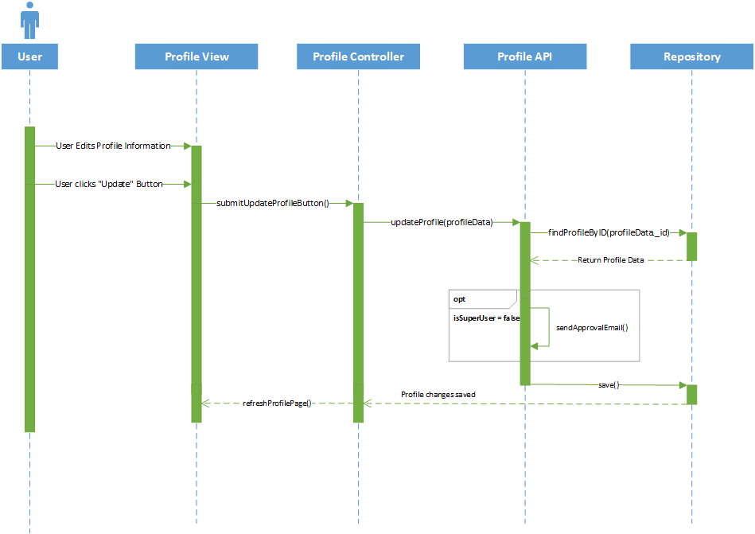

## 

## 

## 

## 

## Unit & Integration Test

**Test Case 1 (Sunny Day)**

**ID: VIP-SD-746-01**

**Purpose**

* Test if user can save information

**Precondition**

* User is signed into VIP
* Is at the profile page

**Expected Result**

* User can update changed information

**Actual Result**

* User updated information

**Test Case 1 (Rainy Day)**

**ID: VIP-RD-746-01**

**Purpose**

* Test if user can leave required fields empty

**Precondition**

* User is signed into VIP
* Is at the profile page

**Expected Result**

* User is not able to save with empty fields

**Actual Result**

* User was able to save information with empty fields

**Visual User Guide**

1. **Login to website**

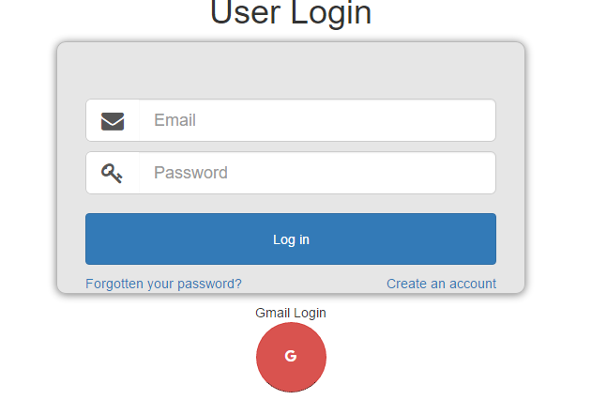

1. **Open Profile Page**

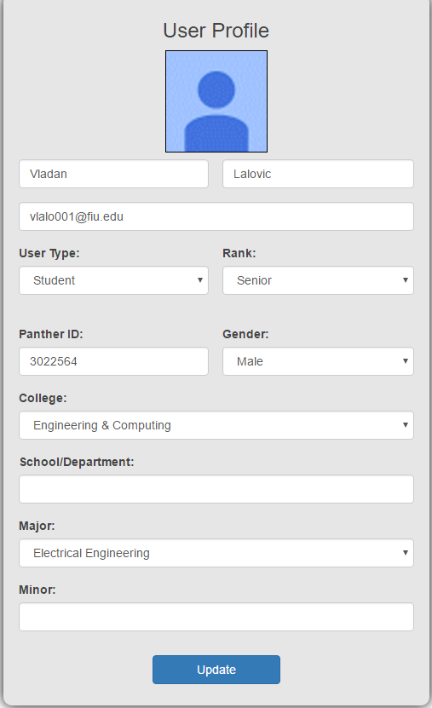

1. **Fill in changes, and press “Update”.**

